**KINDERGARTEN SUPPLY LIST**

* 2 Hardcover composition notebooks for primary grades. The pages look like this inside. **NO REGULAR NOTEBOOKS PLEASE.**

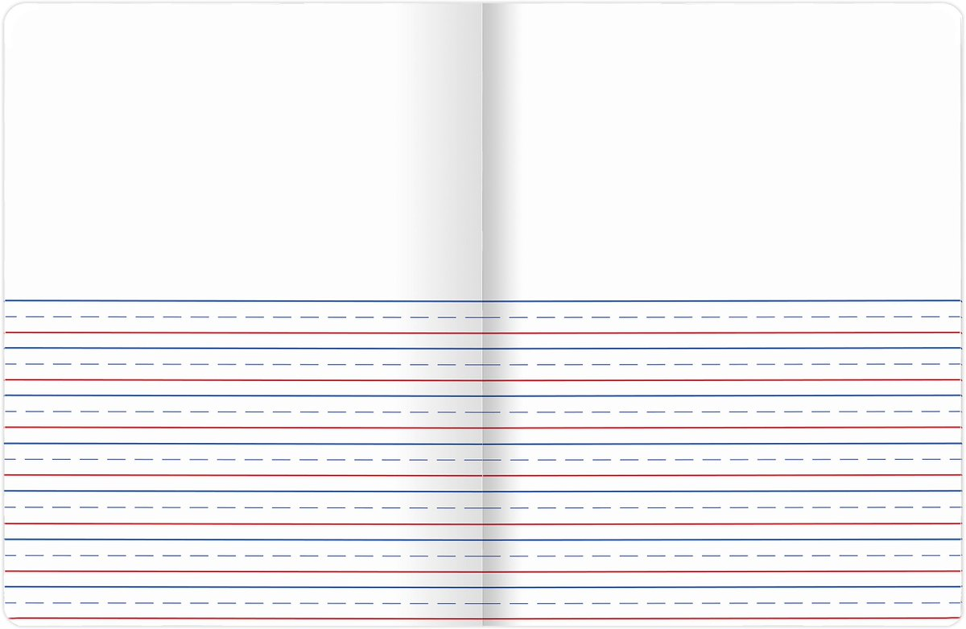

* 1 **PLASTIC 3-PRONG FOLDER** (they last much longer) 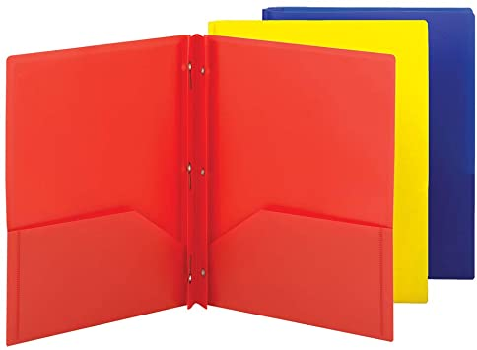
* Bookbag that can fit a folder and hang on hook or seat. No wheeled bags, please.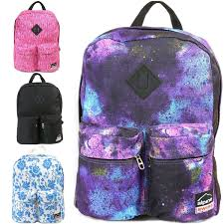
* 1 refillable water bottle 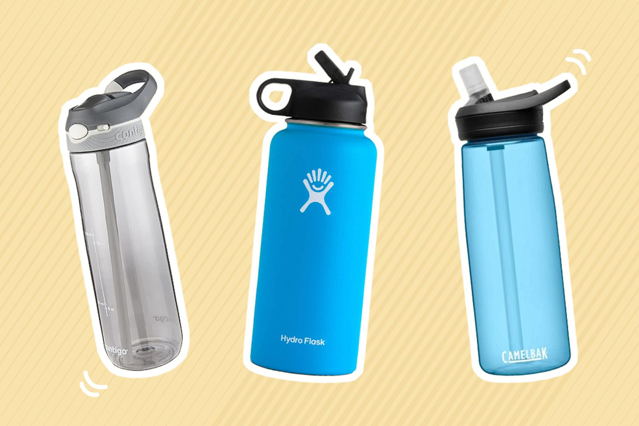
* One plastic pencil case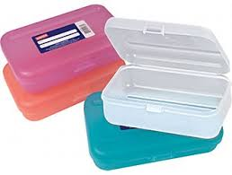
* 1 pack of beginner pencils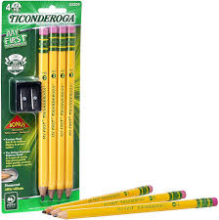
* 2 Packs of 24 crayons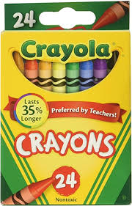
* 1 Pack of dry erase markers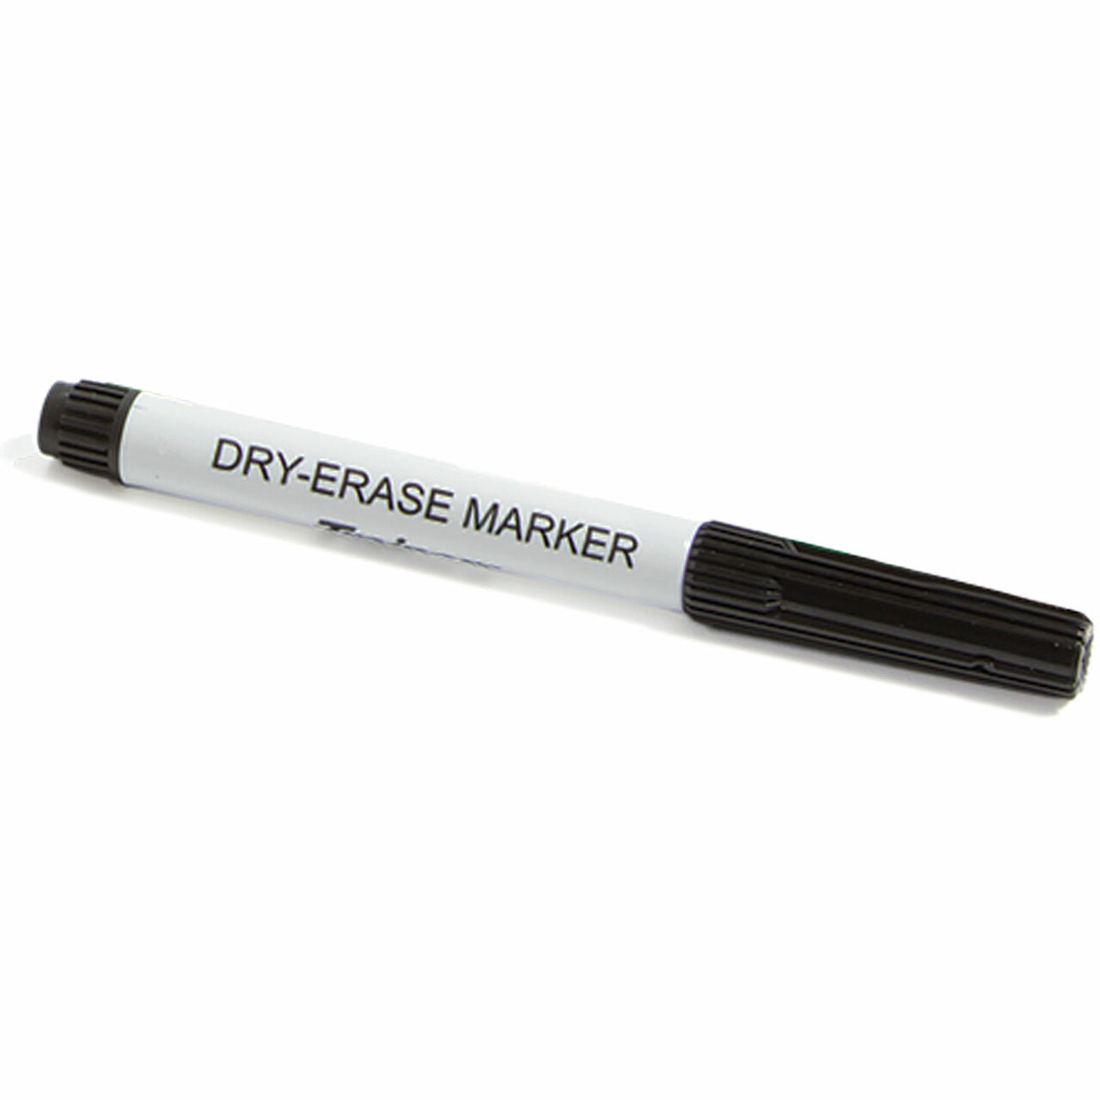
* 8 Large glue sticks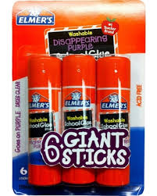
* 2 glue bottles 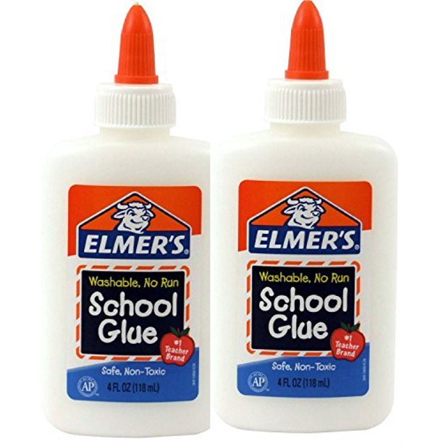
* 2 pink erasers 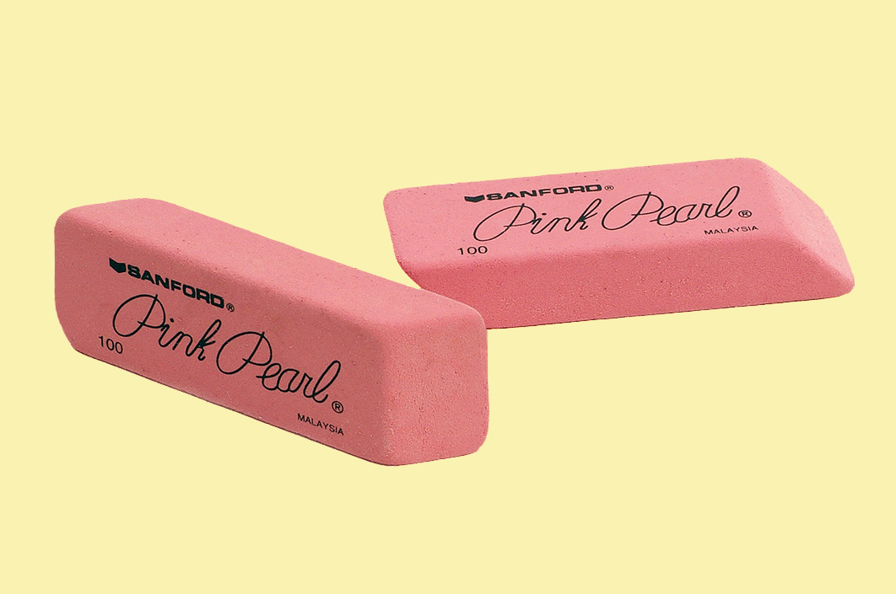
* 1 child safe scissors 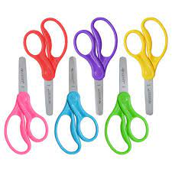
* 2 packages of watercolor paint 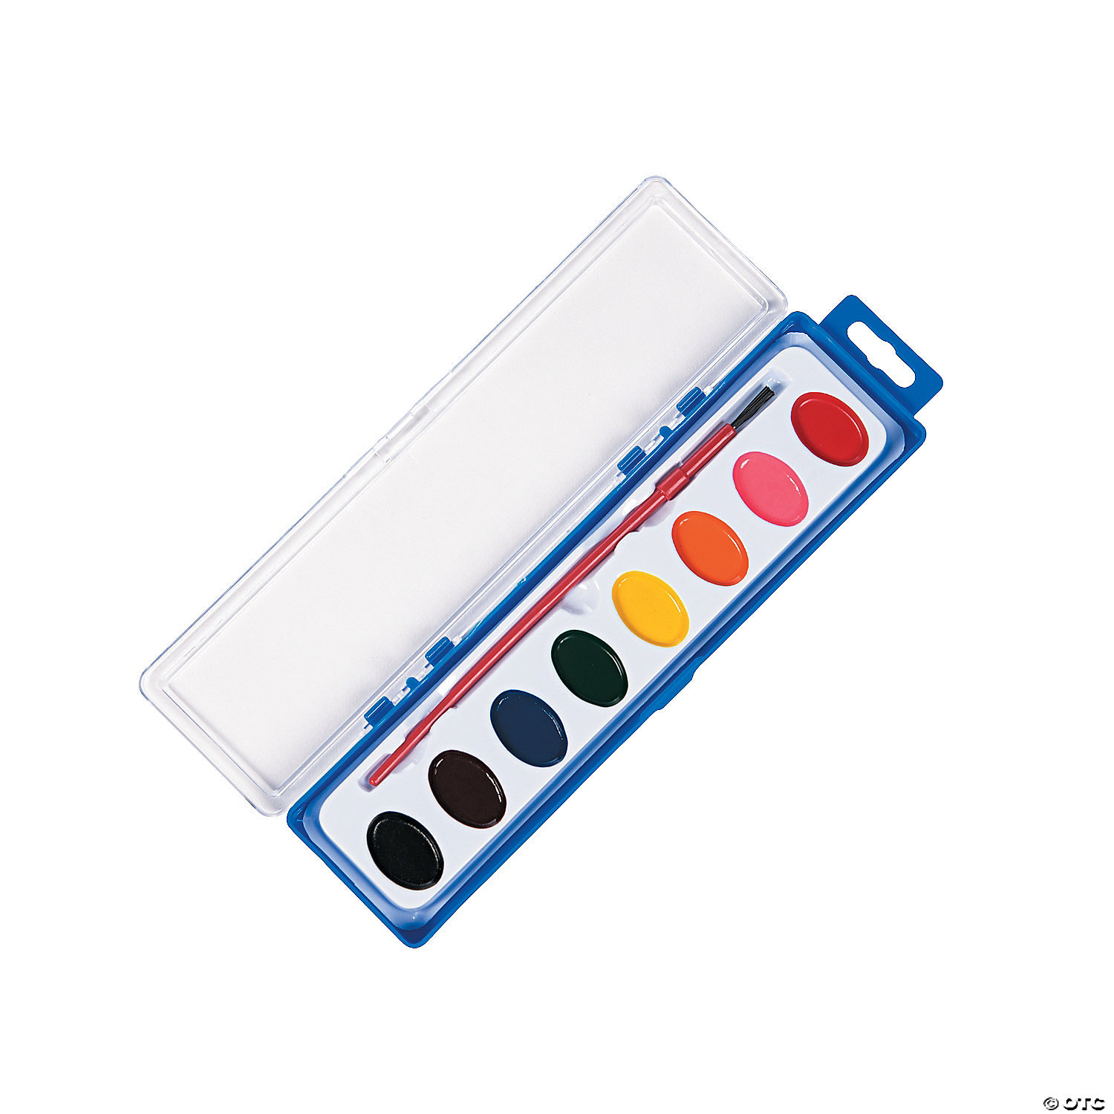
* 1 package of 4 playdoh 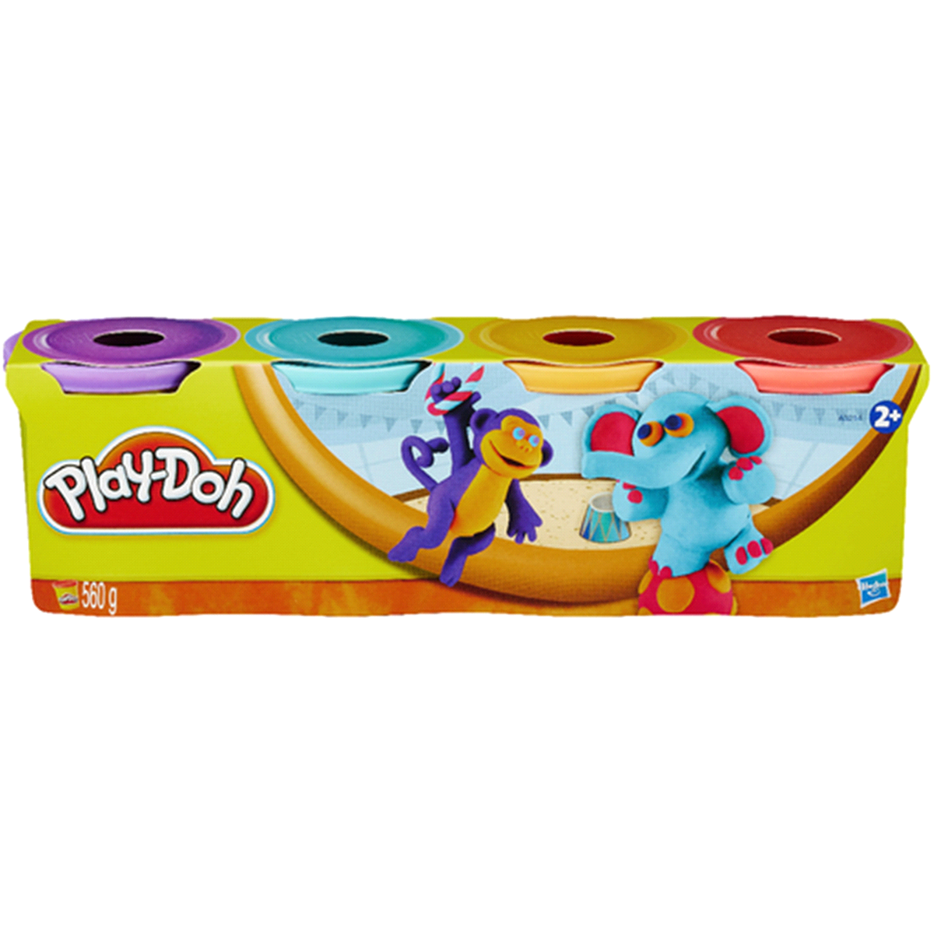
* 1 pack of copy paper 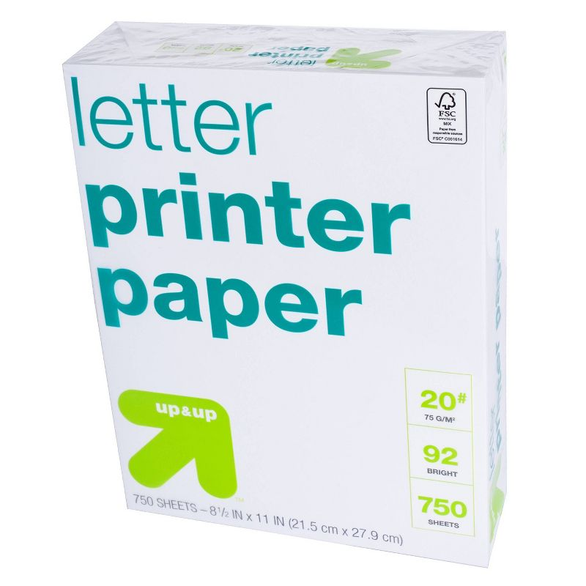
* 2 Boxes of tissues 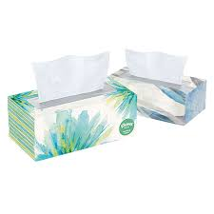
* 1 Roll of paper towels 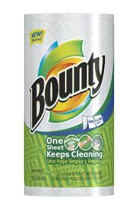
* 2 packs of baby wipes 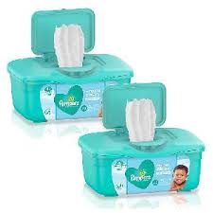
* 1 pack of disinfecting wipes 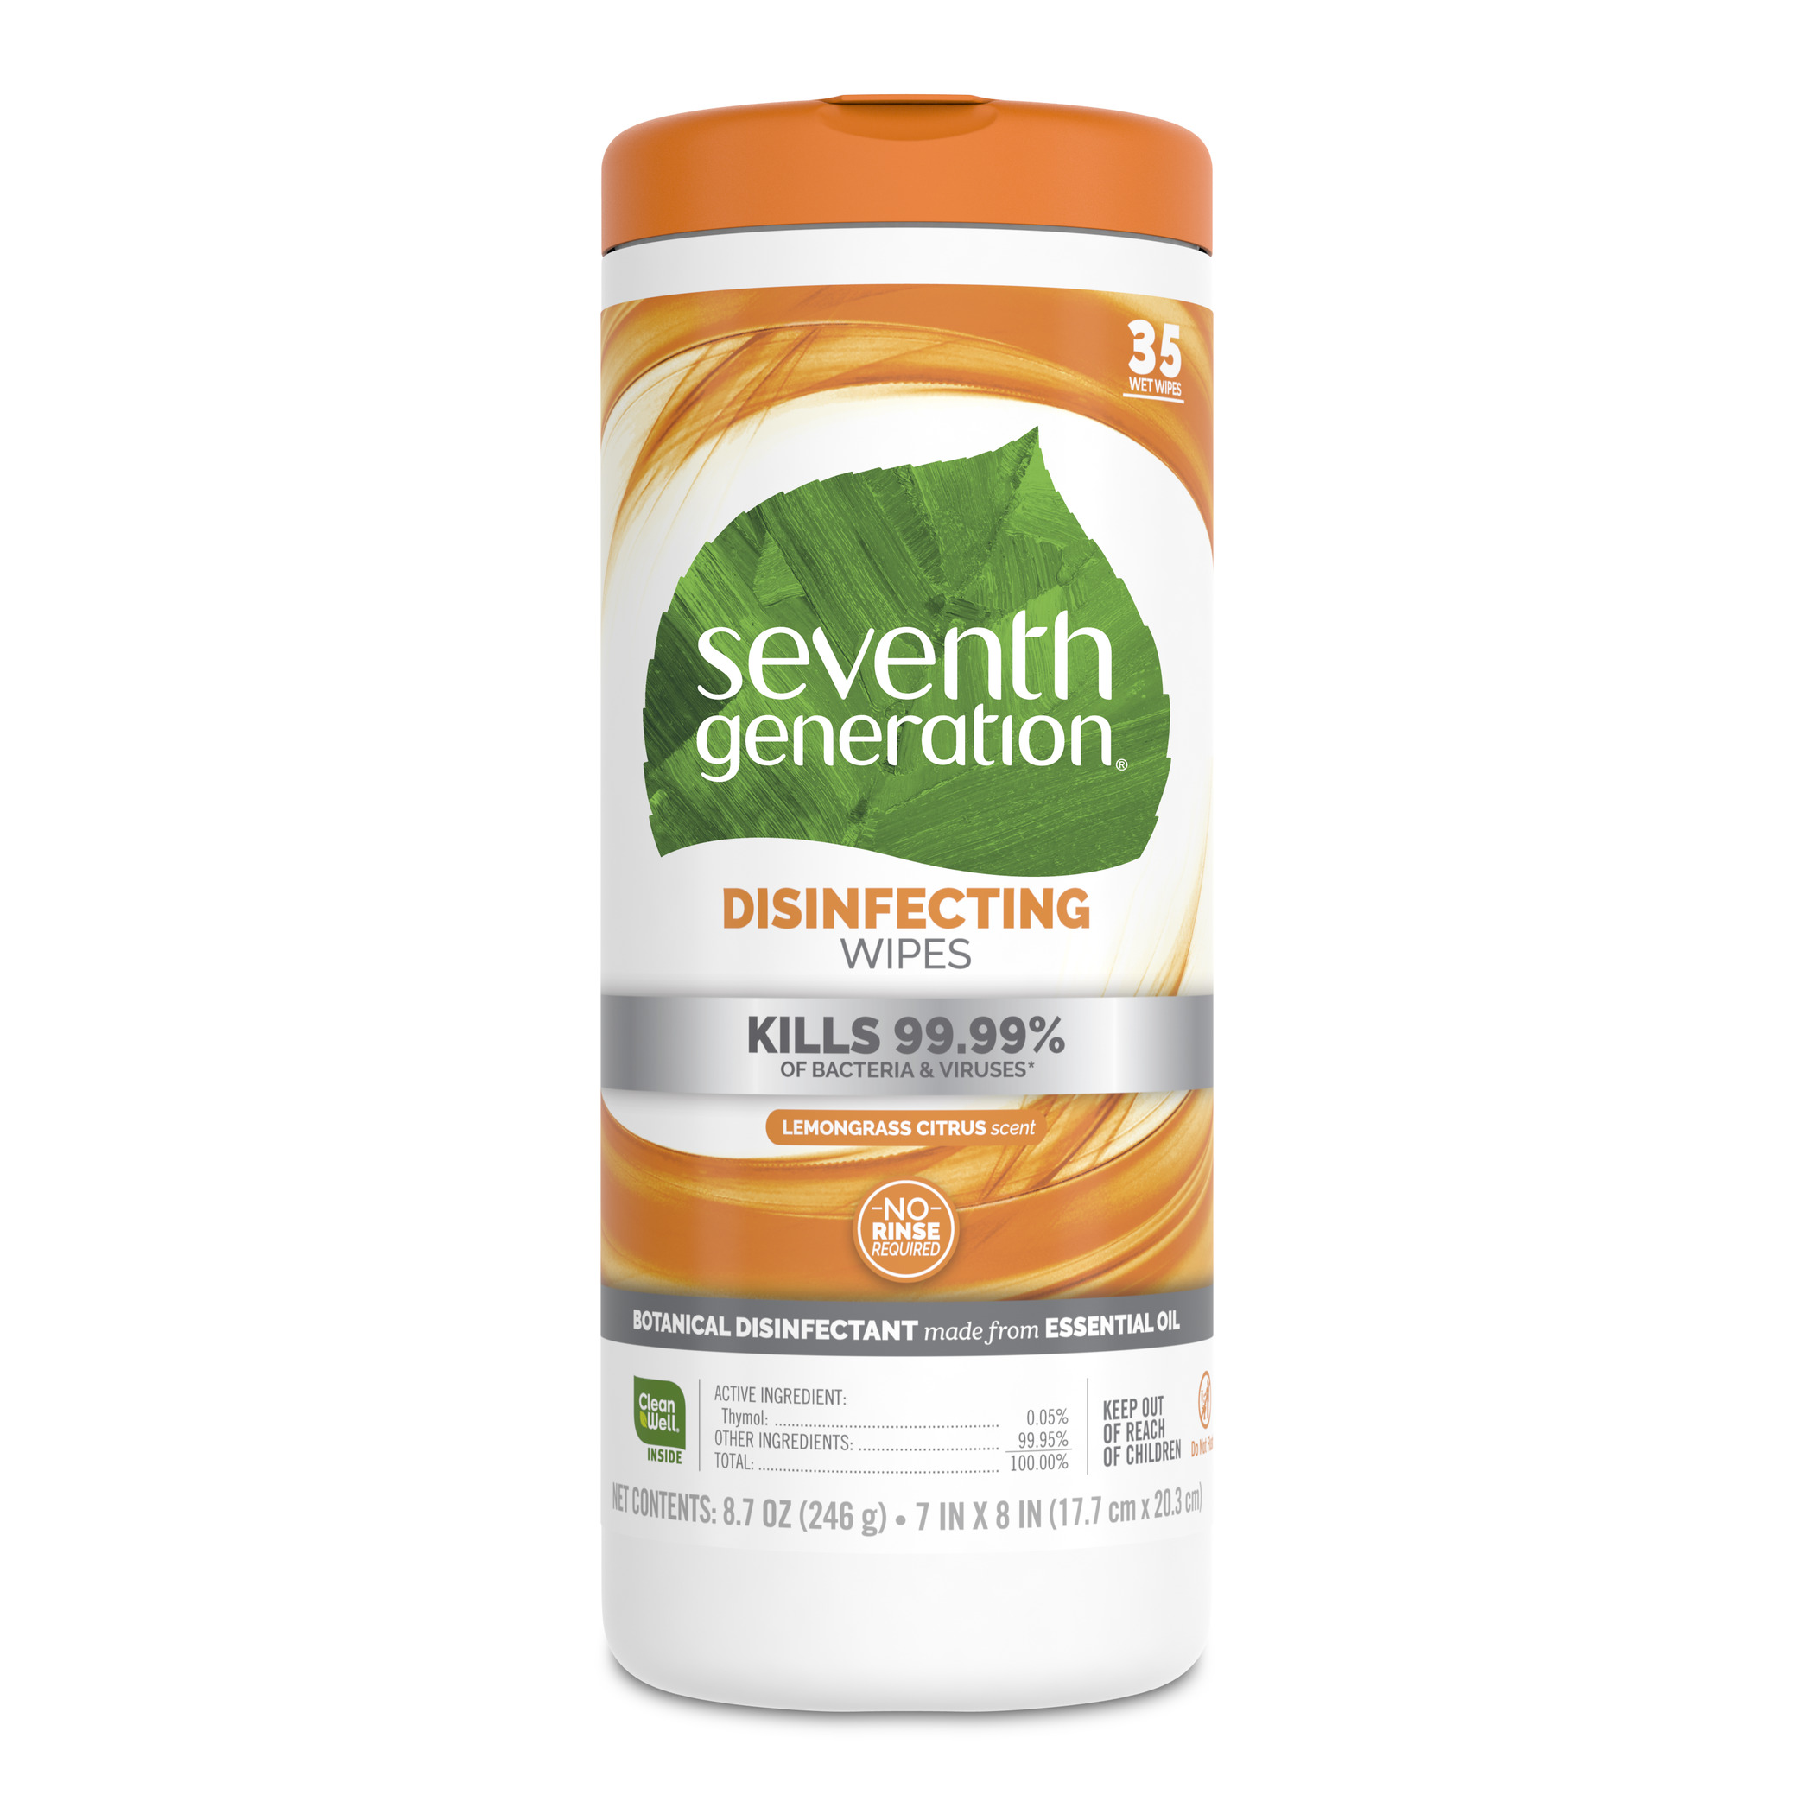
* 1 hand sanitizer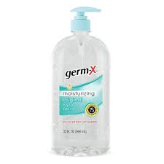
* 1 Complete change of clothes. Please include socks and underwear, and an extra pair of sneakers if you have them. Put in baggie with their name on it.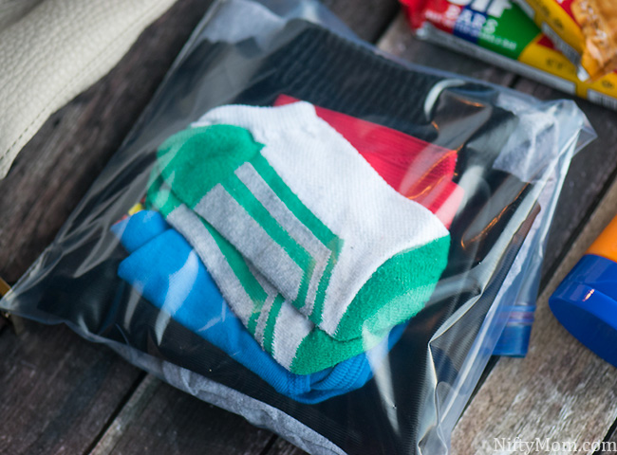

**PLEASE LABEL EVERYTHING SENT TO SCHOOL FOR YOUR CHILD**

We know everything is expensive. Nothing must be brand name; everything can be found in dollar stores. Thank you and we look forward to meeting you!

Kindergarten Teachers

Mrs. Llenin and Dr. Smallwood